PERT Diagram

**Activity** **Immediate Predecessor** **Time (weeks)**

A Preparation of ISR -- 2

B Preparation Requirement Spec A 3

C Preparation of Design Spec A, B 4

D Prototype Development C 4

E Conduct System tests D 2

F Refine & Finish System D, E 1

F Develop & Test Module 3 D, E 15

G Conduct Comprehensive Sys Test E 12

H Refine & Hand Over System F, G 08

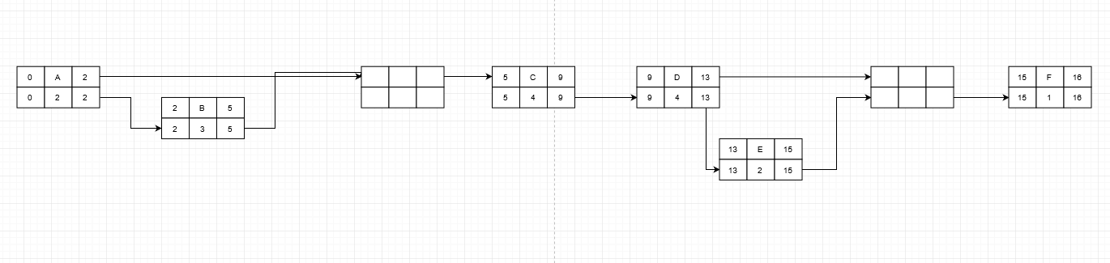

CRITICAL PATH: {A, B, C, D, E, F}

Duration: The total duration for this project is limited to 16 weeks, keeping on the critical path is a must.

Total Slack: slack = LS – ES 🡪 16 – 0 = 16 weeks